**LITTLE ANIMAL HORROR ZOO**

**GROUP 7 IS HEAVEN**

**USE CASE DIAGRAM.**

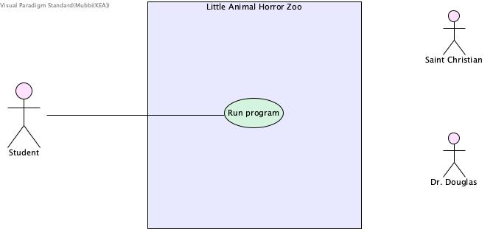

**DESCRIPTION.**

* Student creates IntelliJ file.
* Student creates Animal class and Main class.
* Student creates attributes for Rabbit, Snake, name x and y in animal class.
* Student creates constructor in animal class.
* Student creates getName in animal class.
* Student creates get and set methods for x and y in animal class.
* Student creates if/else method for moveAnimal in animal class.
* Student creates toString method in animal class.
* Student creates new p1 and p2 with the starting point for the rabbit and snake in main class.
* Student creates if else statement with print out statements with the coordinates of rabbit and snake in main class and print out statement for when rabbit and snake are on the same square.
* Student creates print out statements for when rabbit and snake are withing one square of each other.
* Student runs program.

**USE CASES. (for now – perhaps we only need run program)**

* *Create Snake and Rabbit attributes.(?)*
* *Create setLocation method for point.(?)*
* *Create input for starting points for Rabbit and Snake.(?)*
* *Create translate method.(?)*
* *Create grid.(?)*
* *Create print statements for Rabbit and snake positions.(?)*
* **RUN PROGRAM**

**Primary Actors**

Student

**Secondary Actors**

???

**Supporting Actors**

Saint Christian (lol)

**Pre-Conditions (Is this needed?)**

Rabbit and snake must be able to move individually.

Rabbit and Snake must be able to state their current locations.

Snake must be able to state that it is close to rabbit.

Snake must be able to state that it is going to eat the rabbit.

**Minimum Guarantees**

Student must be able to successfully run program

**Success Guarantees**

Basic flow

* Program runs without issues.

Alternate flow (?)

* Runs with issues